Performative differences between different electrochromic devices

Bram Vanderwegen

*Electrochromic displays have a wide range of application and a lot of potential for further use. These devices can be subdivided into two categories: powered electrochromic devices and self-powered electrochromic devices. The self-powered variant is especially interesting as it does not require any external power source to operate Furthermore, these applications are limited by the construction and performance of the devices. This paper will go into detail on the performance. The performance can be subdivided into three categories: amount of cycles the device can handle, the transmittance value and by extension the color and the speed at which the devices change color. This paper aims to clarify the performance for an array of materials and electrolytes used in order to facilitate choosing a material for an application with its specific requirements.*

# INTRODUCTION

Electrochromic displays already have a long history of development and during this development a multitude of different materials were used. These materials can vary in their way construction, their color, their switching speed, their durability etc.

The construction of electrochromic display consist of an anode, a cathode, a ion storage medium, the electrochromic material and the electrolyte. In some applications as mentioned down below, the electrolyte can be combined with ion storage layer.

The functional principle of an electrochromic device is based on the phenomenon of electrochromism. This occurs when a device undergoes a change in color upon the application of an electric field. On a molecular scale, the electrochromic material interacts with ions by accepting electrons from the electrode, leading to a redox reaction. This process causes the material to undergo coloration.

Conversely, when an electric field is removed, electrons and ions migrate away from the electrochromic display. This movement results in the electrochromic material entering a higher state of oxidation, altering its transmittance and increasing its ability to absorb photons. As a consequence, the device 'bleaches' in color, returning to a less colored or transparent state. This dynamic interplay of electron and ion movement within the electrochromic material provides the visual effect of color change. [1]

Applications of these devices in mainly in the display technology. The main ones here are “smart windows”, these windows can change their transmittance and allow controlling the amount of light that can pass through it. These come in their own variety of applications from windows on buildings to visors on motorcycle helmets. The main advantage over other technologies is the low energy consumption. [2]

# Materials used

This paper discusses a total of seven different electrochromic devices. The first one using a Nickel Oxide (NiO) material with a KOH electrolyte. This device had a rather high cycling rate. [3]

The second device uses a Tungsten trioxide (WO3) material and a LiClO4/CAN/PMMA polyelectrode. This device had a really low transmittance change. [4]

The third one uses Prussian Blue (PB) electrochromic material and a KCl electrolyte. [5]

The fourth and fifth material are alike as they both use the same electrolyte construction consisting of PAM/LiCl. The materials used are PB and Nickel hexacyanoferrate (NiHCF). [6]

The sixth device uses WO3 material and a solid electrolyte, this electrolyte will not be discussed in this paper. [7]

The seventh device uses WO3 material and a LiClO4 electrolyte. [8]

# Self-powered and powered device

There are two ways to make a electrochromic device change color. One way is applying an external voltage across electrodes, the powered device. And by letting it short and regenerate naturally by oxidation, the self-powered device. To change the color of a self-powered device, the procedure is straightforward, a voltage needs to be applied in one direction to bleach it and in another direction to color it. A self-powered device works by shorting the device, causing it to bleach and then remove the short to let the material oxidize and automatically regain its color. Typically a powered device changes color more quickly because it has an external power source to drive the reaction. Self-powered devices are slower in switching color, especially in the coloring process where the slower oxidation reaction takes place. This can clearly be seen in table 2 down below where the times are in function of power type.

Note the coloring time for index 3 and 5 where due to the oxidation reaction the change time is in orders higher than the bleaching times

# electrolyte materials

When working with different materials, different electrolytes need to be chosen in order to accommodate the functionality of the devices. These electrolytes each have their own properties and influence the other characteristics such as the switching speed and durability. The electrolytes purpose is to move the charges in the device and cause the material to change color. The electrolytes discussed in this paper can be subdivided into two categories: Potassium (K) based electrolytes and Lithium (Li) based electrolytes.

Lithium is used as an agent which enhances the bleaching effect by rapidly inserting itself into the material film. [6] Furthermore it causes certain materials such as WO3 to exhibit electrochromic effects. [4] Another additive enhancing the reaction is (NH4)2S2O8. This chemical acts as an oxidizer and enhances the coloring effect by acting as a main driver behind the reaction next to ambient oxygen.

Another factor concerning the electrolyte is the construction of the device. Multiple types of electrolyte exist for constructing a device. These are usually in the shape of a solid-state electrolyte, an aqueous electrolyte or a gel electrolyte. Solid-state electrolytes are straightforward as they can be made using the same techniques used to make other parts of the device. Aqueous electrolytes have the advantage of being easy to apply and adding chemicals, but are more difficult to contain. Gel-based electrolytes are a novel technology, using a gel, this allows them to be flexible without needing to be physically constrained to the device. Furthermore other chemicals can easily be added to them. [6]

# amount of cycles

The amount of cycles a material can go through a specific for a material and electrolyte used. Furthermore additional chemicals can change the amount of cycles it can go through. The above mentioned (NH4)2S2O8 is a chemical used to increase the coloring speed, but it is consumed during the oxidation process. Therefore this acts as a limiting factor for the amount of cycles. Consequentially a high amount of this chemical can elongate the cycling performance of the device. [6]

Adding a Ti-doped V2O5 film to the device can increase its it cyclability tremendously. As it allows for a better insertion for the lithium ions. This allows the device attain cycling performances magnitudes higher than without the layer as seen with the device at index 6, in table 1, having a cycling performance 200 times higher compared to index 1 and 4000 times the performance of index 3.

The collected data shows the material shows the cycling performance is largely tied to the material used. Table 1 shows the correlation. As PB in both cases have around 50 cycles of functioning, the exception to this is index 6 due to the abovementioned addition.

|  |  |  |  |
| --- | --- | --- | --- |
| index | Material | Electrolyte | cycles |
| 1 | NiO | KOH | 1000 |
| 2 | WO3 | / | 50 |
| 3 | PB | KCl | 50 |
| 4 | PB | PAM/LiCl | 55 |
| 5 | NiHCF | PAM/LiCl | 25 |
| 6 | WO3 | LiClO4/PC | 200000 |

Table 1: amount of stable cycles in function of device [3] [7] [5] [6] [8]

As a large part of the electrochromic devices is their capacitor-like behavior, and because it is an easier to quantify variable. A lot of the cycling behavior was measured in retained capacity after cycling for x amount of cycles.

# transmittance value

The transmittance value signifies the percentage of light that is allowed to pass through de device in its initial and bleached state. This, furthermore is in function of the wavelength of light. The transmittance . Different materials exhibit different colors both in initial and bleached states. Therefore it is difficult to effectively quantize the value. The practical approach is to use the visible aspect, as this will be its primary use case. The most visible aspect is its change between color, in other words the change in transmittance is a desirable variable.

|  |  |  |  |
| --- | --- | --- | --- |
| index | Material | Electrolyte | transmittance |
| 1 | NiO | KOH | 63.60% |
| 2 | WO3 | / | 44.10% |
| 3 | PB | KCl | 21.30% |
| 4 | WO3 | LiClO4 | 5.90% |
| 5 | WO3 | LiClO4/PC | 85% |

Table : average transmittance change between coloring and bleaching [3] [7] [5] [4] [8]

This comparison illustrates the importance of the specific construction used for the device as for example the WO3 materials have vastly different transmittance values.

# cycling speed

A large part in the useability of electrochromic displays is the time which it takes to bleach and switch back the color. These values reach from a couple of seconds to multiple hours. The speed of the color change is logarithmically and therefore a value 90% to the extrema have been defined as the point of having switched the color, they are denoted as Tb and Tc for bleaching and coloring respectively.  
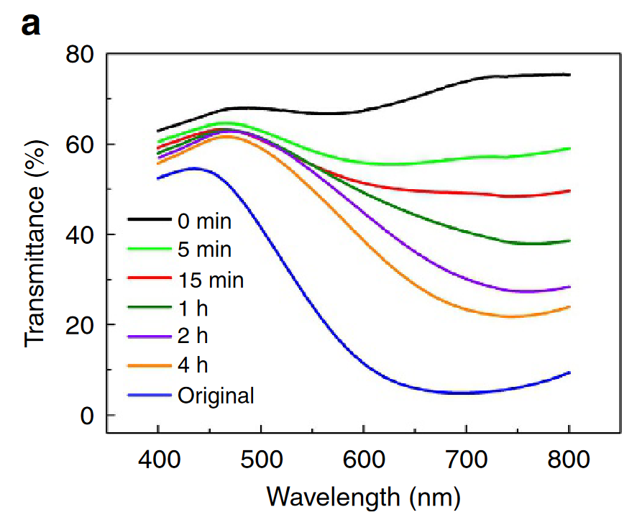

Figure : example of the logarithmic behavior of changing color [5]

|  |  |  |  |  |  |
| --- | --- | --- | --- | --- | --- |
| index | Material | Electrolyte | Tc | Tb | powered |
| 1 | NiO | KOH | 11.5s | 9.5s | yes |
| 2 | WO3 | / | 1.7s | 1s | yes |
| 3 | PB | KCl | 590s | 10s | no |
| 4 | PB | PAM/LiCl | 19s | 18s | no |
| 5 | NiHCF | PAM/LiCl | 1290s | 8.5s | no |
| 6 | WO3 | LiCLO4… | <10s | <10s | no |

Table 2: time comparison between powered and self-powered devices [3] [7] [5] [6] [4]

The table shows the cycling speed varies between bleaching and coloring. Usually the bleaching time is shorter than the coloring time, especially in the self-powered state. This is due to how the ions migrate. In self-powered devices oxidize themselves using ambient oxygen in order to color. This is a rather slow reaction and therefore requires more time. This can be sped up using the (NH4)2S2O8.

# Conclusion

In conclusion, electrochromic displays present a promising avenue for diverse applications, offering the flexibility of both powered and self-powered variants. The self-powered devices, in particular, stand out for their independence from external power sources. However, the practical implementation of these devices is contingent upon the construction and performance factors that determine their efficiency.

This paper delves into the intricacies of electrochromic displays, focusing on the performance metrics of cycling capability, transmittance values, and cycling speed. The materials and electrolytes employed play a pivotal role in shaping these characteristics. The seven different devices discussed showcase the versatility of materials like Nickel Oxide (NiO), Tungsten trioxide (WO3), and Prussian Blue (PB), each with its unique attributes.

The distinction between self-powered and powered devices highlights the trade-offs in speed, with powered devices generally exhibiting faster color changes due to the external power source. The cycling performance, as measured by the number of cycles a device can undergo, is influenced by factors such as electrolyte composition and the addition of chemicals like (NH4)2S2O8.

The choice of electrolyte, categorized into Potassium (K) and Lithium (Li) based variants, further impacts device functionality. Different electrolyte constructions, including solid-state, aqueous, and gel-based electrolytes, contribute to the overall versatility of electrochromic displays.

Cycling speed, a crucial aspect of user experience, varies significantly among different materials and electrolyte combinations. The logarithmic behavior of color change is evident, with bleaching generally taking less time than coloring, especially in self-powered devices. The role of additives like (NH4)2S2O8 becomes evident in enhancing the coloring speed.

In summary, this paper strives to elucidate the complex relationship between materials, electrolytes, and performance metrics in electrochromic displays. The comprehensive analysis provided here serves as a valuable resource for researchers and practitioners seeking to make informed decisions regarding material selection for specific applications based on cycling capability, transmittance values, and cycling speed requirements. As the field continues to evolve, understanding these nuances will be pivotal in harnessing the full potential of electrochromic displays across a spectrum of technological applications.

# Bibliografie

|  |  |
| --- | --- |
| [1] | multiple, „Electrochromism,” Wikipedia, 8 11 2023. [Online]. Available: https://en.wikipedia.org/wiki/Electrochromism. [Geopend 1 12 2023]. |
| [2] | multiple, „Electrochromic device,” Wikipedia, 29 9 2023. [Online]. Available: https://en.wikipedia.org/wiki/Electrochromic_device. [Geopend 1 12 2023]. |
| [3] | G. Cai, X. Wang, M. Cui, P. Darmawan, J. Wang, A. L. S. Eh en P. S. Lee, „Electrochromo-supercapacitor based on direct growth of NiO nanoparticles,” *Nano Energy,* pp. 258-267, 1 3 2015. |
| [4] | X. Yang, G. Zhu, S. Wang, R. Zhang, L. Lin, W. Wu en Z. L. Wang, „A self-powered electrochromic device driven by a nanogenerator,” *Energy & Environmental Science,* pp. 9462-9466, 18 10 2012. |
| [5] | J. Wang, L. Zhang, Y. Le, Z. Juao, H. Xie, X. W. Lou en X. Wei Sun, „A bi-functional device for self-powered electrochromic window and self-rechargeable transparent battery applications,” *Nature Communications 2014 5:1,* pp. 1-7, 23 9 2014. |
| [6] | W. Xue, Y. Zhang, F. Liu, Y. Dou, M. Yan en W. Wang, „Self-Powered Flexible Multicolor Electrochromic Devices for Information Displays,” *Research,* 14 9 2023. |
| [7] | L. Shen, L. Du, S. Tan, Z. Zang, C. Zhao en W. Mai, „Flexible electrochromic supercapacitor hybrid electrodes based on tungsten oxide films and silver nanowires,” *Chemical Communications,* pp. 6296-6299, 28 4 2016. |
| [8] | Y. Wei, J. Zhou, J. Zheng en C. Xu, „Improved stability of electrochromic devices using Ti-doped V2O5 film,” *Electrochimica Acta,* pp. 277-284, 1 6 2015. |
| [9] | OpenAI, „Chatgpt,” OpenAI, [Online]. Available: https://chat.openai.com. [Geopend 12 1 2023]. |
| [10] | „Transactions-template-and-instructions-on-how-to-create-your-article-formatted_4.pdf,” [Online]. Available: https://sscs.ieee.org/images/files/Transactions-template-and-instructions-on-how-to-create-your-article-formatted_4.pdf. [Geopend 1 12 2023]. |